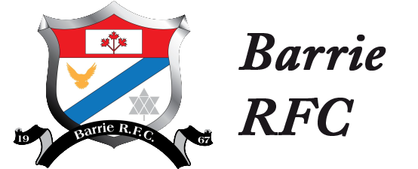

**Mini Rugby Program**

**HOW TO REGISTER YOUR CHILD**

*Just follow these easy directions!*

Go to the Barrie Rugby Club website at [www.barrierugbyclub.com](http://www.barrierugbyclub.com) and select “Teams” from the drop down Menu, then select Youth and finally your age group. Scroll down the screen and click on the blue box marked “Register Now”. When you click on this link it will take you to the Rugby Canada registration system, if this is your first time registering your child for rugby you will need to set up your own account with Rugby Canada which is easy enough to follow. Once you have set up your account you need to enter the parent contact details, emergency contact details and some basic information about your child. If you have more than one child you can enter them all under one account.

Once your child’s information is entered you select them for actual registration. The system takes you through a few information request screens until you get to a screen where you select the type of Membership you want. On this screen select the full “Athlete Membership” option. At the bottom of this screen click both the Minor Rugby Player options. This covers your child’s Membership fee for Rugby Canada of $30 (please note this is included in the fee we charge above, it is not an additional fee). Click Continue at the bottom of the screen and the next screen it takes you to is the Provincial Membership section where you select Minor Rugby Player again. This is your child’s provincial membership fee for Ontario Rugby of $30.35 (once again this is included in the fee we charge above, it is not an additional fee).

Click on Continue and it takes you to the Club Fee option and you select the age your child is playing. Next page you sign the electronic waiver and then hot Continue. You get one final screen that allows you to make any changes you want to and then you check out to your shopping cart and make the payment by credit card. Once this is done you should receive a confirmation email that you registered successfully. If you have more than one child you have to follow this process for each child.

It sound a bit convoluted but once you are in the system it is intuitive enough.

**ORDERING YOUR CHILDS RUGBY KIT**

*As soon as* you have registered and paid for your child please order your kit by following the directions provided on the separate kit ordering directions form. In order to get your kit customised with your child’s name you need to register and order the kit before April 15, 2017 or we cannot guarantee the shirt will have your child’s name on the back.